**Perfect Word Game Template**

Modulette ID:

Game #

Game title: Spotlight

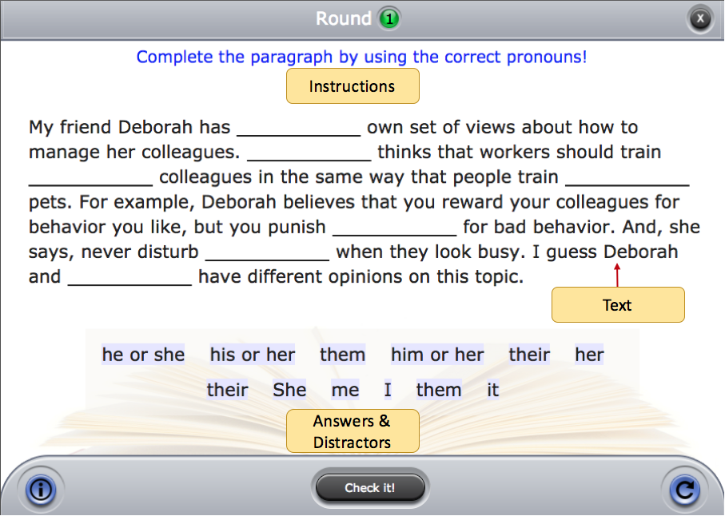

**Instructions:** (Use if the instructions are the same for the entire game)

Round #

**Instructions:** (Use if the instructions are round specific)

**Prompt:** (Rarely used for this game, but is available and can be text or image)

**Correct feedback:** (Feedback that will display when correct answers are selected)

**General incorrect feedback:** (Feedback that will display if any incorrect answer is selected)

**Text and Correct answers:** See example below. The [correct answers] go in brackets. Overwrite the example with the text for the round.

|  |
| --- |
| My friend Deborah has [her] own set of views about how to manage her colleagues. [She] thinks that workers should train [their] colleagues in the same way that people train their [their] pets. . . |

**Distractors:** See example below. List the incorrect words or phrases that will appear with the correct answers in the word pool. [Groups of words] that are meant to be selected as a group should be put in brackets. Overwrite the example with the distractors for the round.

|  |
| --- |
| [his or her] [he or she] it me [him or her] |